19. Using Raptor – Draw and validate a flowchart for a given string of lower-case English alphabets.
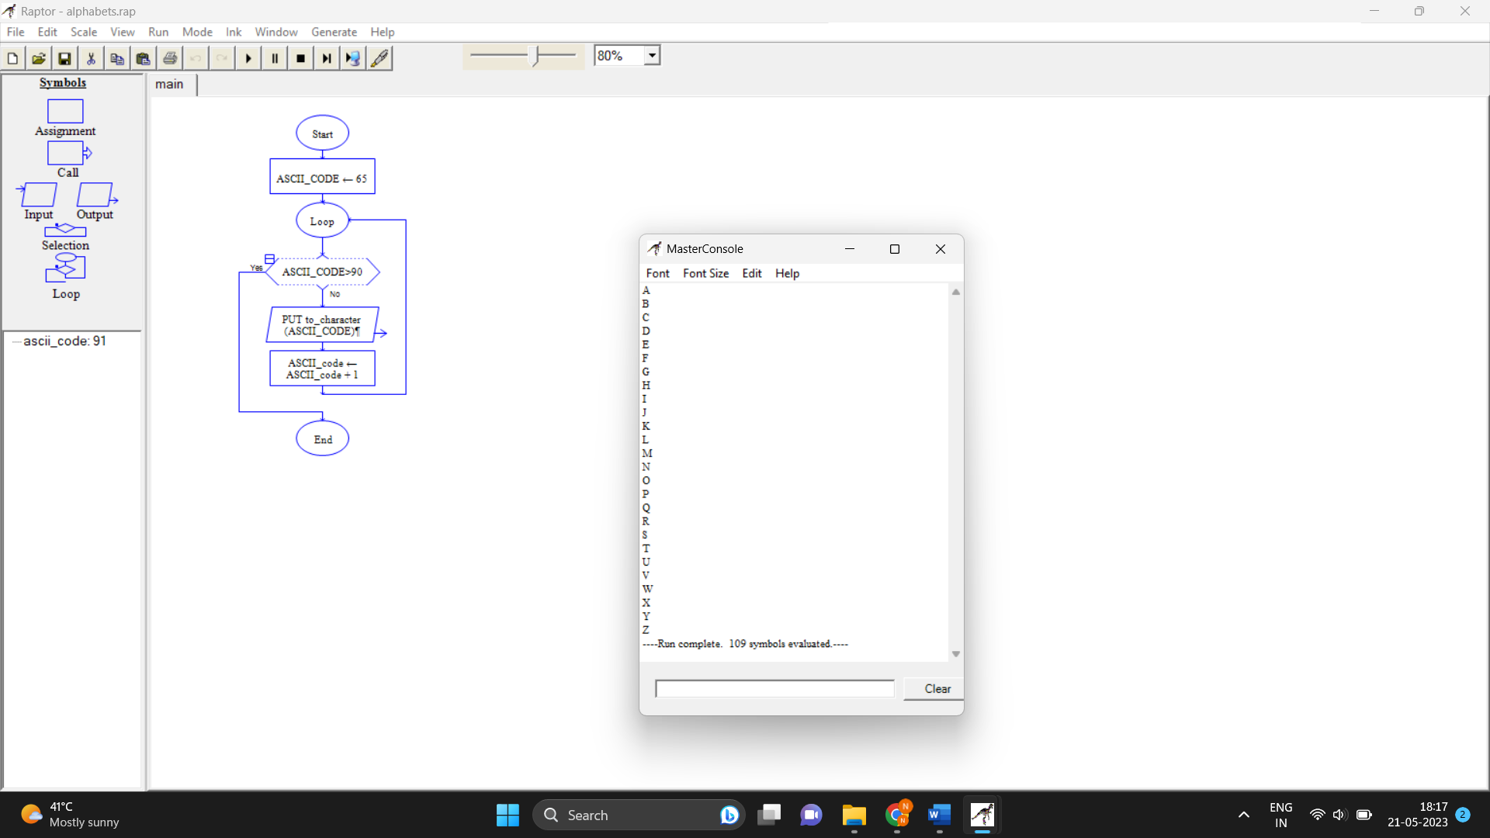

20. Using Raptor draw the flowchart to display the total number of characters in the string and returns it.

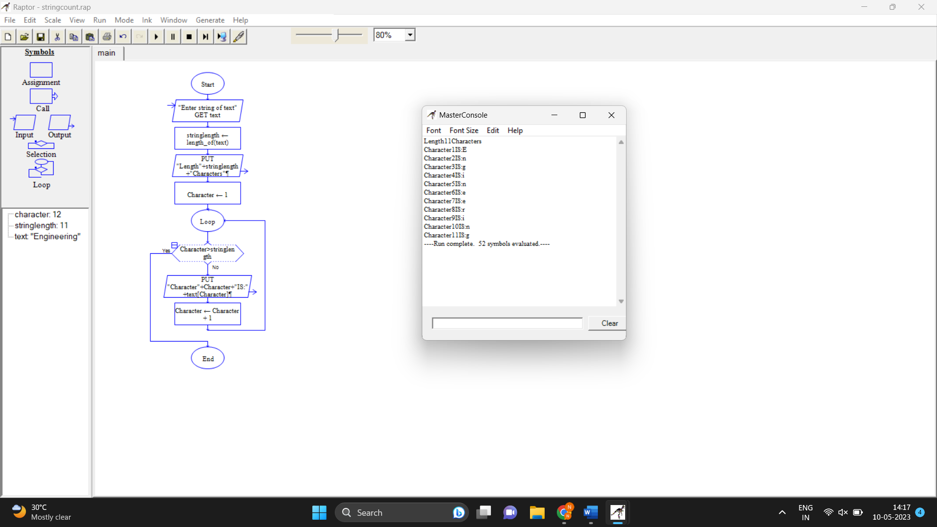

21. Using Raptor draw the flowchart to find whether p and q are prime or not.

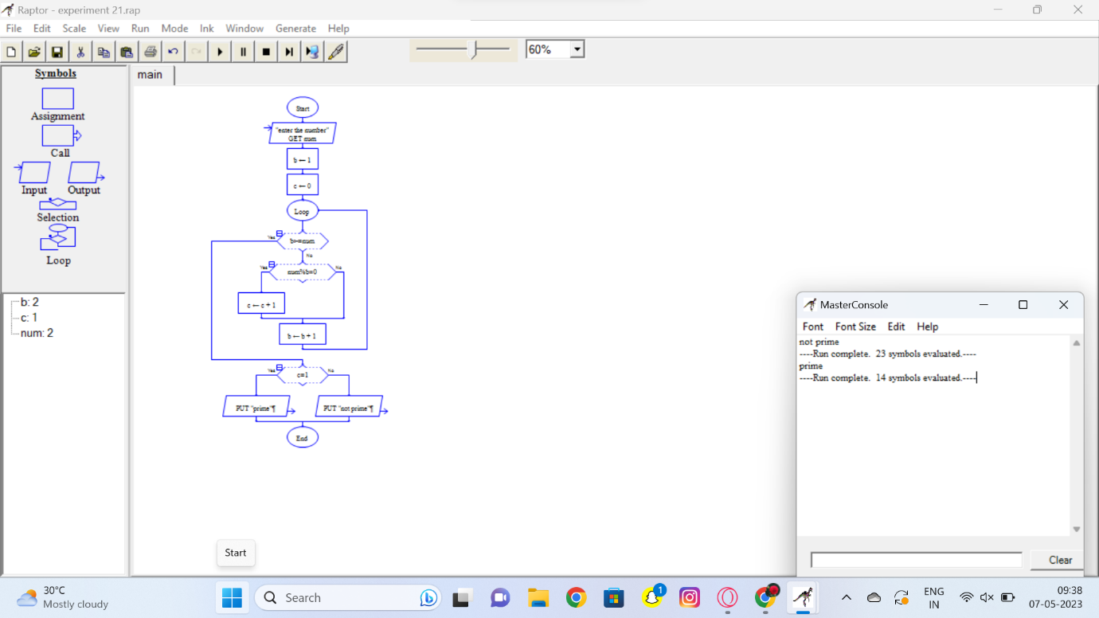

22. Find Cyclomatic Complexity for a graph having number of edges as 17, number of nodes as 13 and number of predicate nodes in the flow graph as 5.

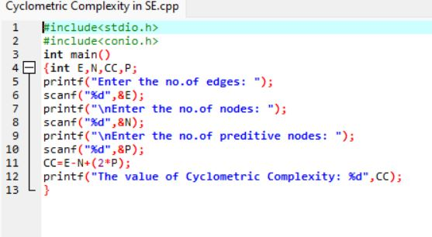

23. Automated online banking system – Activity diagram
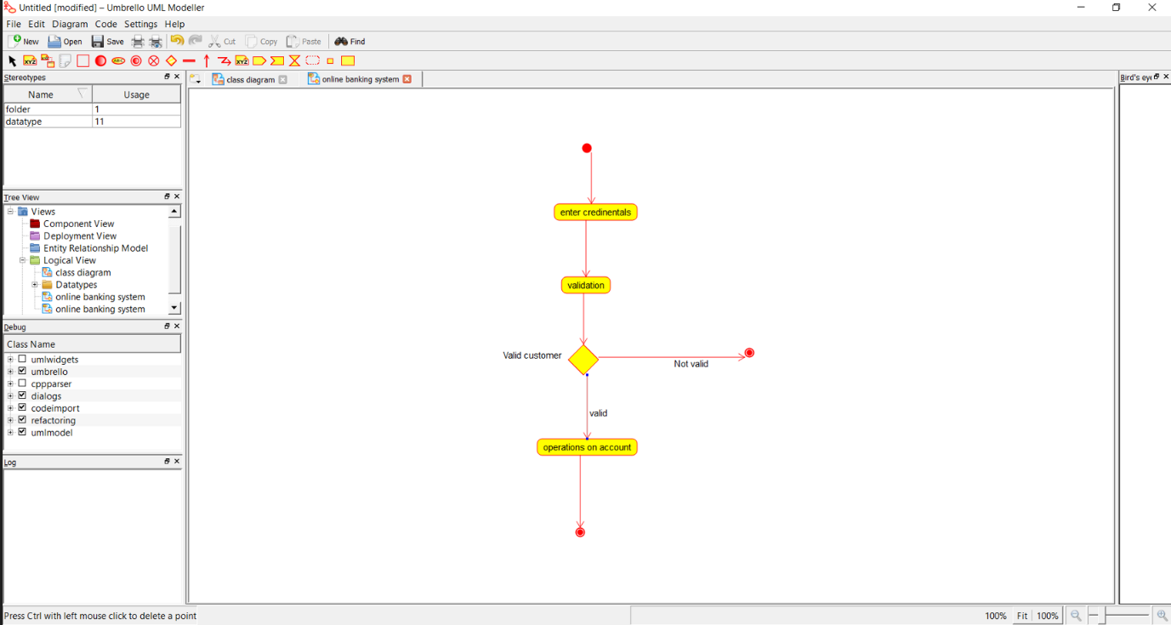

24. E-library online public access catalogue – Activity Diagram

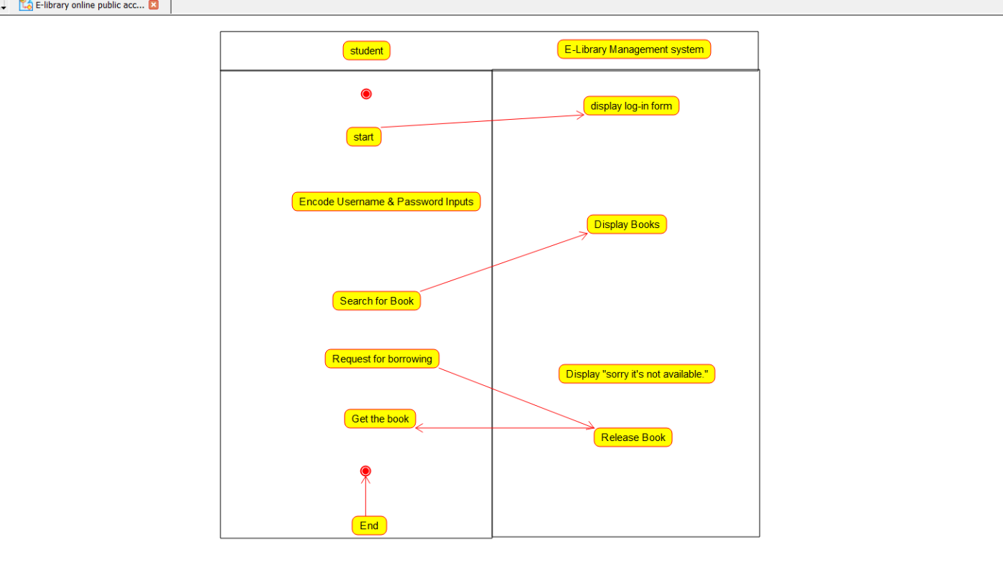
25. E-library online public access catalogue – Class Diagram

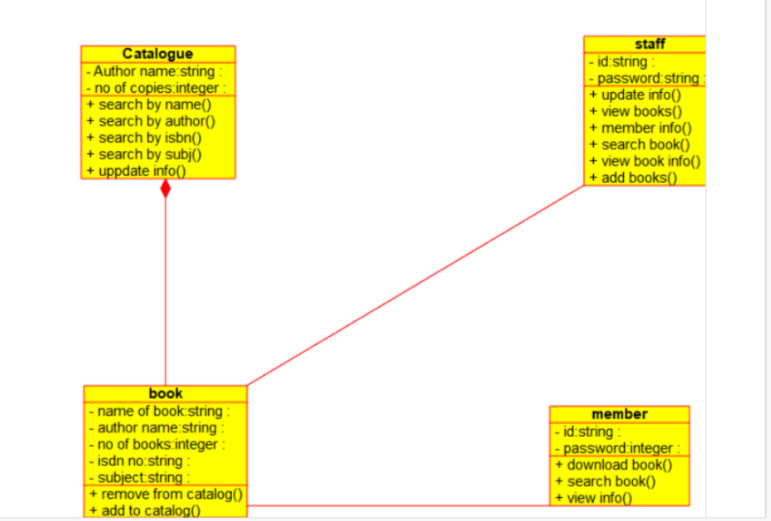

26. Use Case diagram - Restaurant Systems.

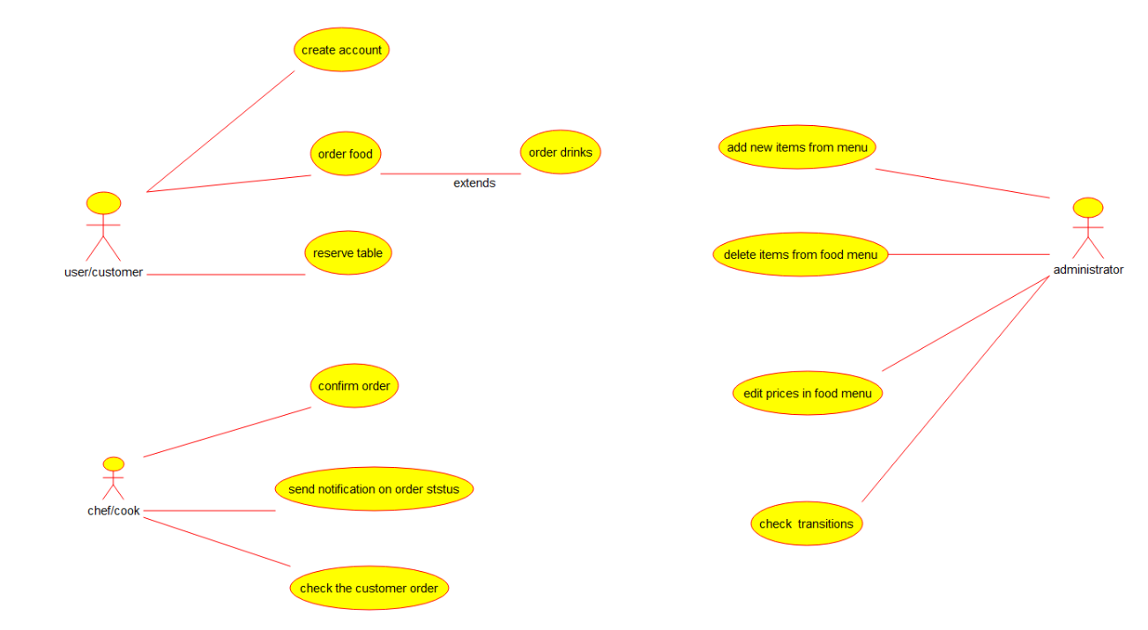

27. Class diagram - Restaurant Systems

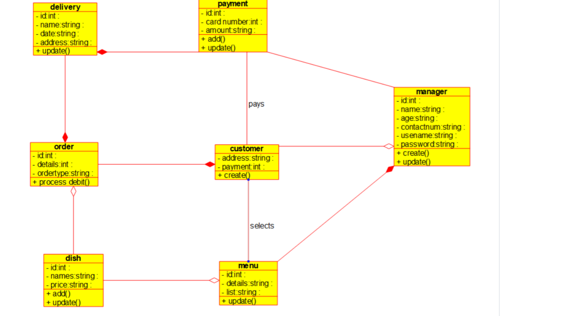

28. Class diagram - Quiz system
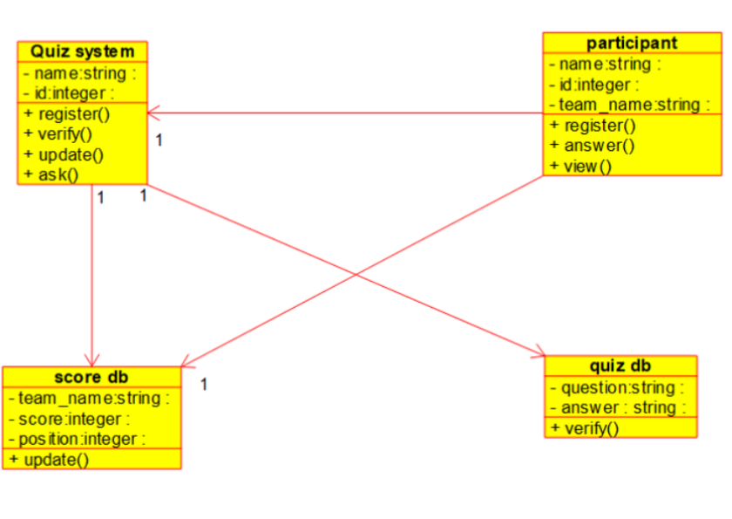

29. Use case diagram - quiz system

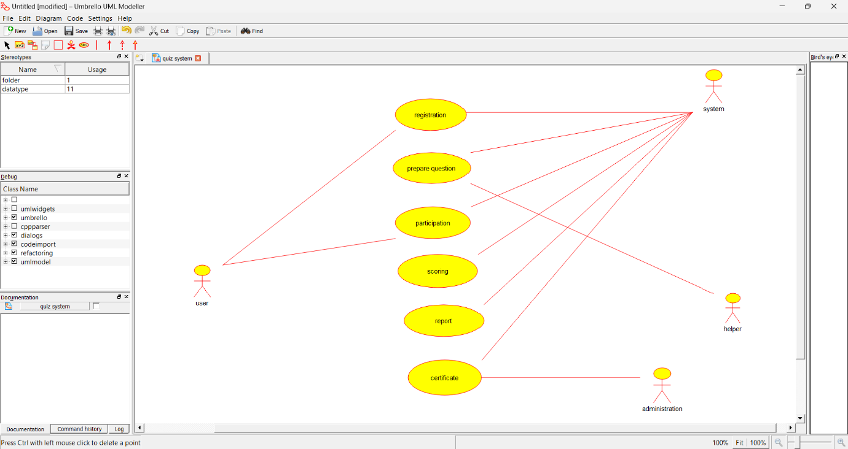

30. Factorial – Raptor

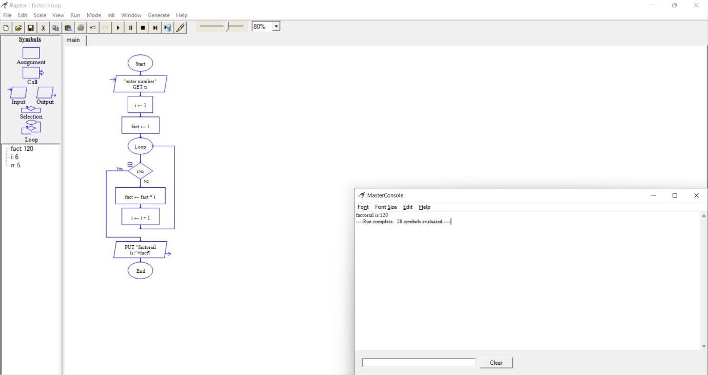

31. Odd and Even series – Raptor
Odd series

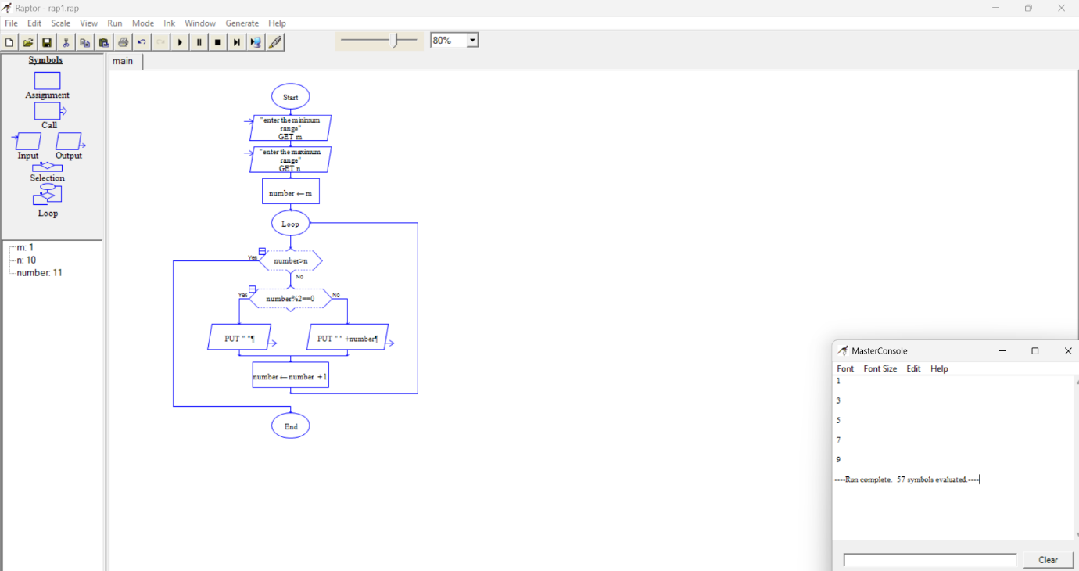

Even series

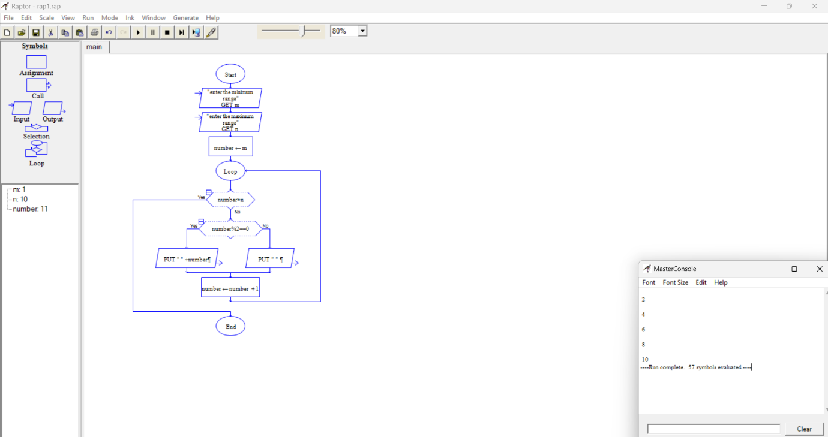

32. Reverse string – Raptor

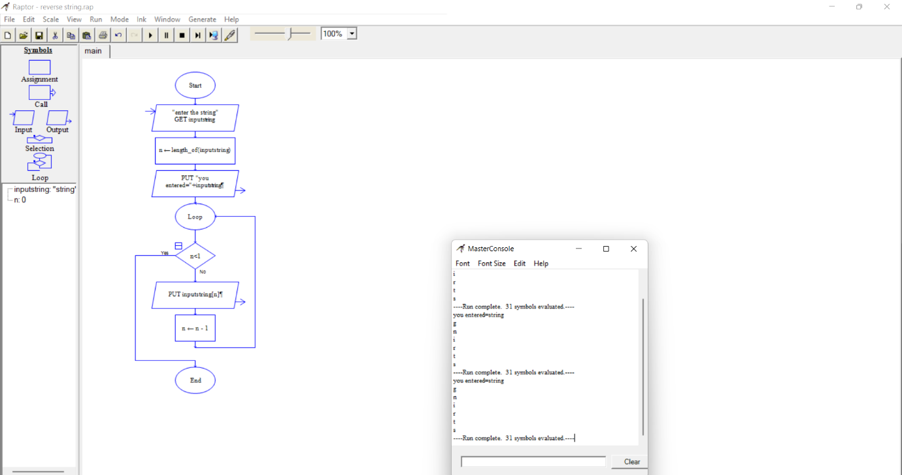

33. Sum of first n natural number – Raptor

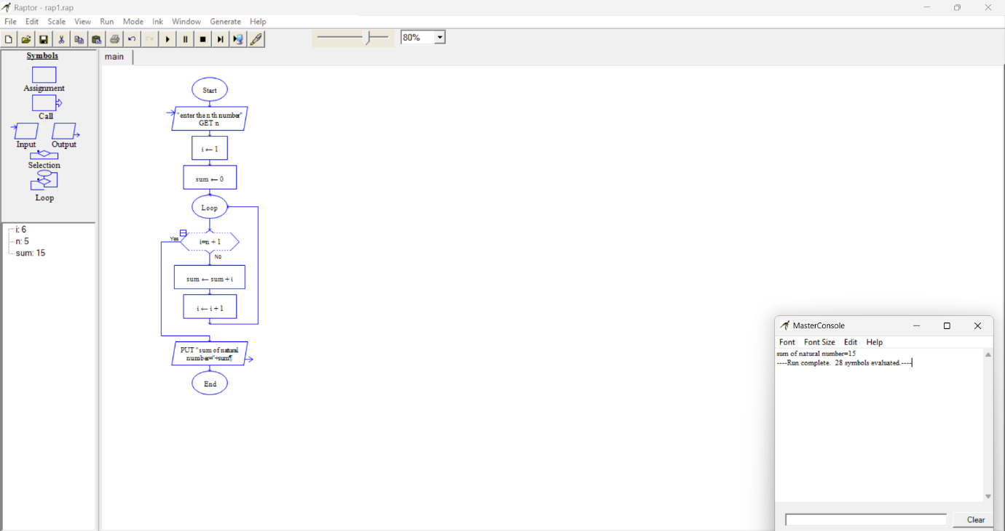

34. Largest of n numbers – Raptor

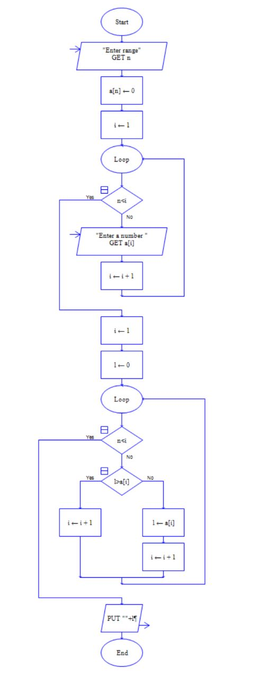
35. Fibonacci Series – Raptor
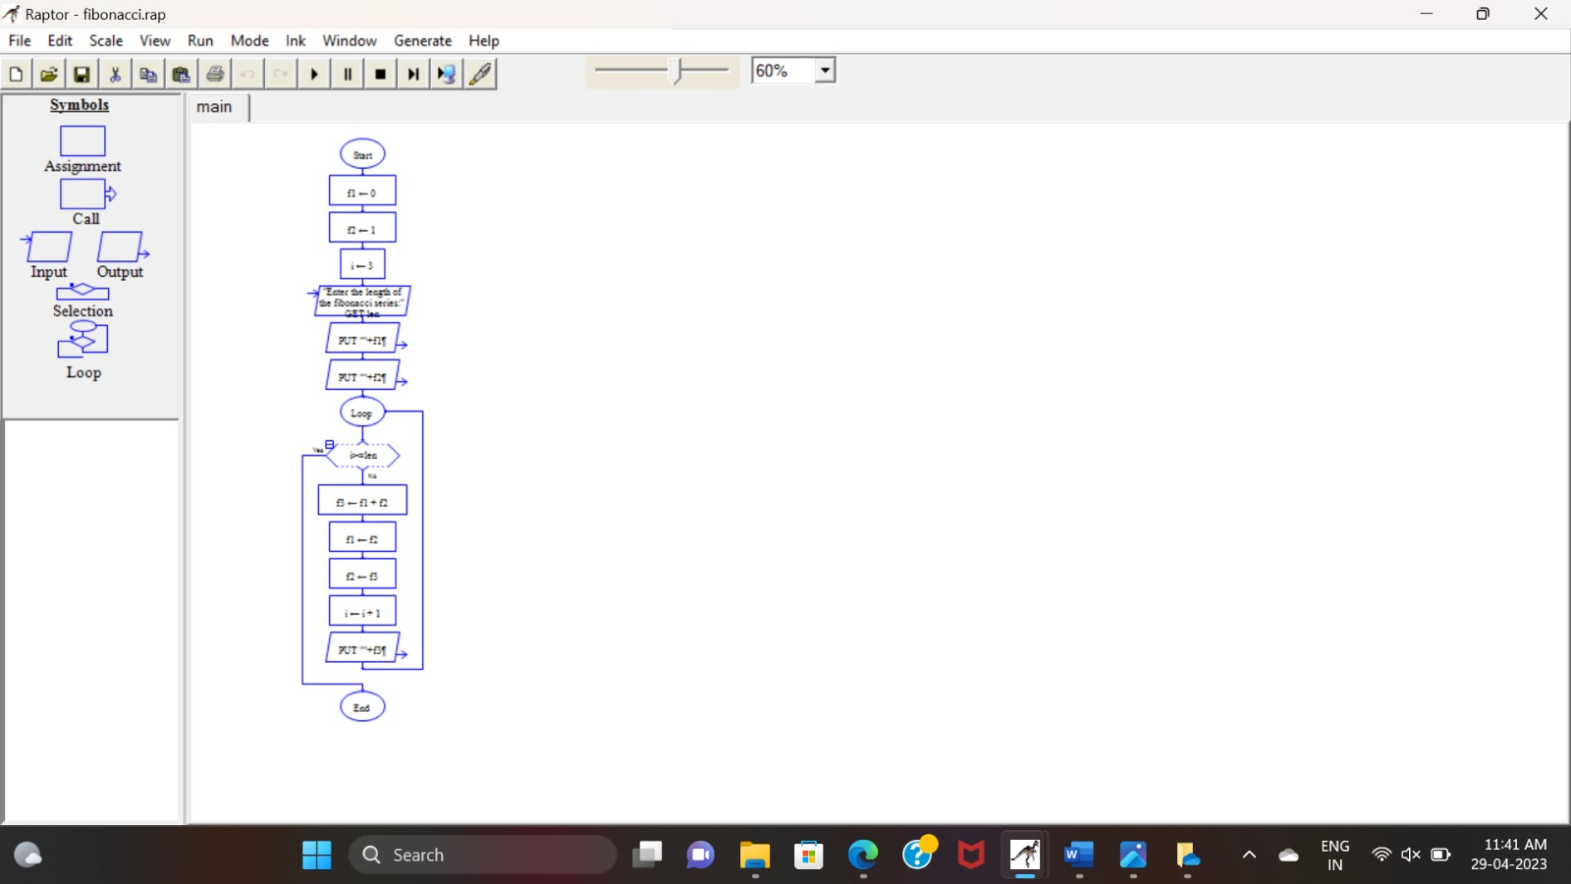
36. Smallest number evenly divisible by each number 1 to N.

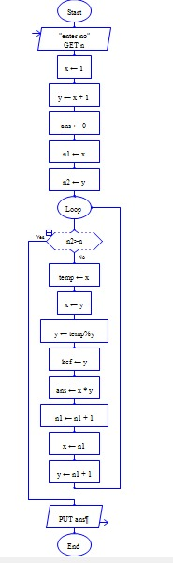

37. E-Wallet Management System (EMS) using Use case diagram

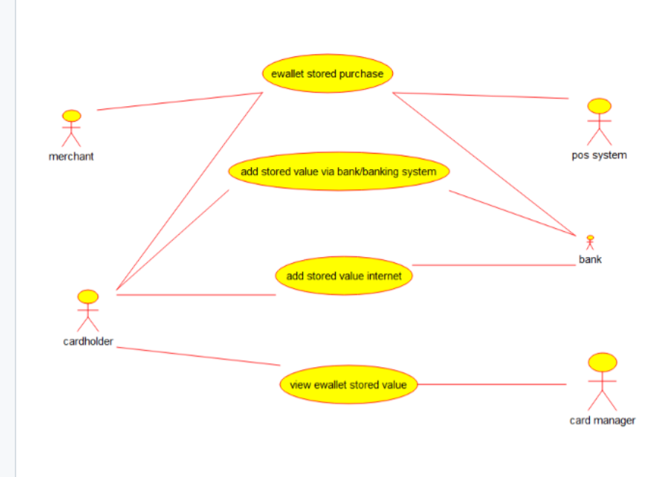

38. Online security management system using class diagram

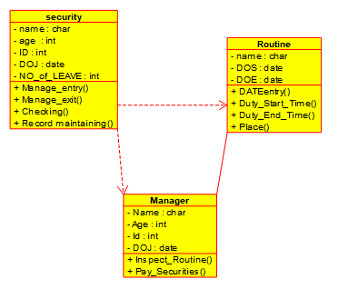
39. Online voting

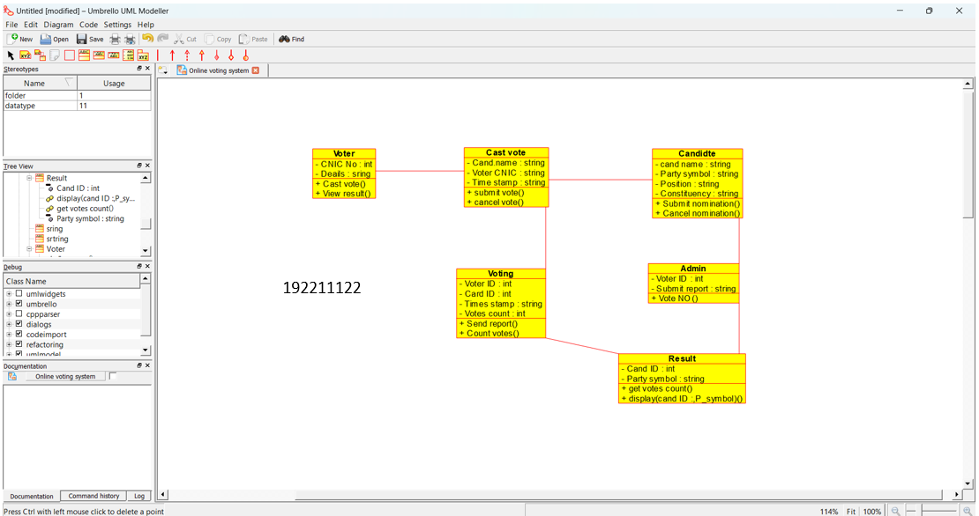

40. Check whether a string is palindrome or not – Raptor

